Learners Academy Project

Developer Name :- Nikhil Rambhau Waware

**Screenshots of all the related** **Scenarios in the Application:**

1. **Admin Login Page :-**

**1.1** Admin login page or Home Page.

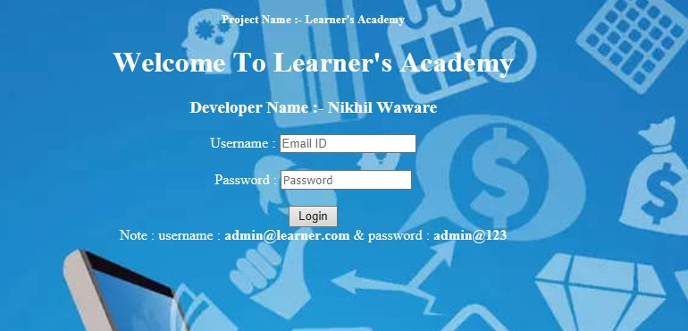

* 1. After entering correct username and password, it will redirect to the Admin Page.

1. **Admin Page :-**

In admin page, there are the options to add student, add teacher, add subject and add class.

And the other options are View students list, teacher list, subject list, class list and class report.

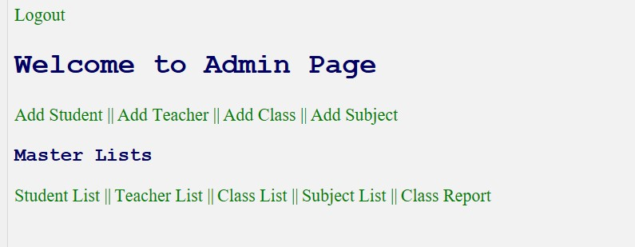

**2.1** **Add Student:-**

Enter details such as student name, roll number and class.

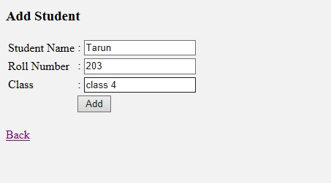

After entering the data, it will show the student record added successfully message. And two links, one is to go back to the previous and another is to go to admin page.

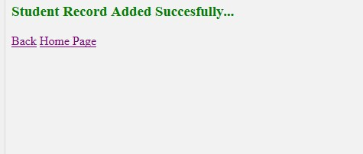

* 1. **Add Teacher :-**

Enter details like teacher name, subject name and class.

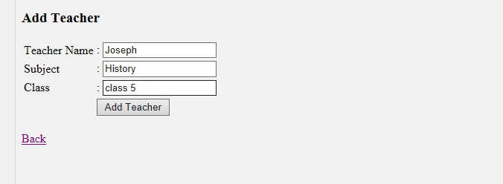

After entering the data, it will show the teacher details added successfully message. And two links, one is to go back to the previous and another is to go to admin page.

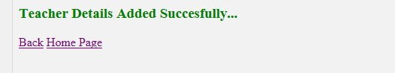

* 1. **Add Class :-**

Enter details like class name and section.

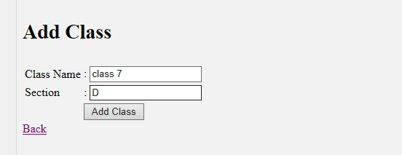

After entering the details, it will show class added successfully message. And two links, one is to go back to the previous and another is to go to admin page.

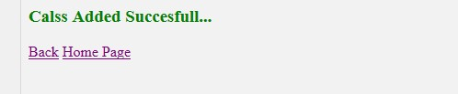

* 1. **Add Subject :-**

Enter subject details like subject name, teacher name and class.

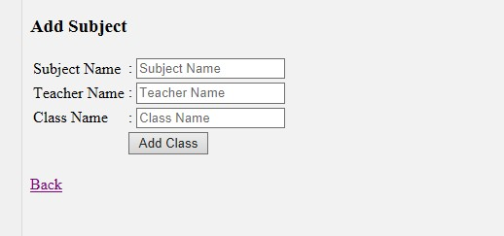

Subjects will get added successfully.

1. **Master Lists**

Here is the master lists of student, teacher, subject, class and class report.



**3.1 Student List :-**

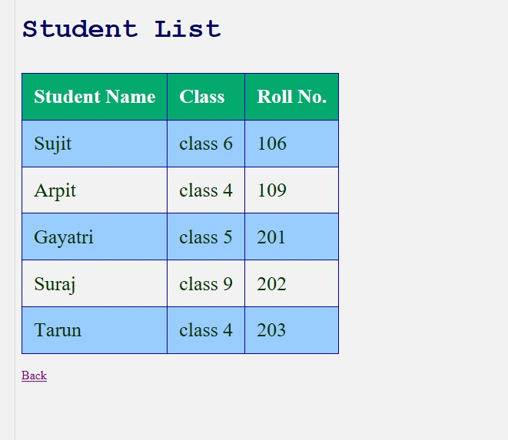

* 1. **Teacher List:-**

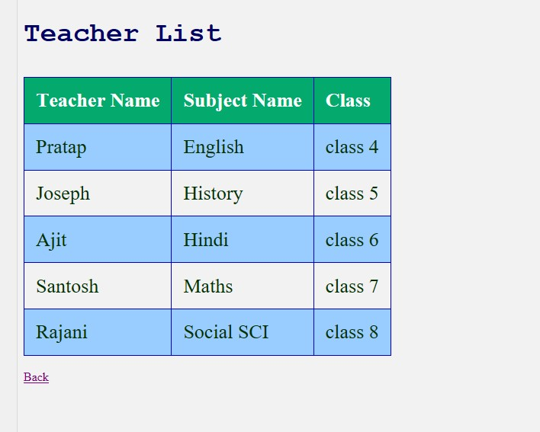

* 1. **Class List:-**

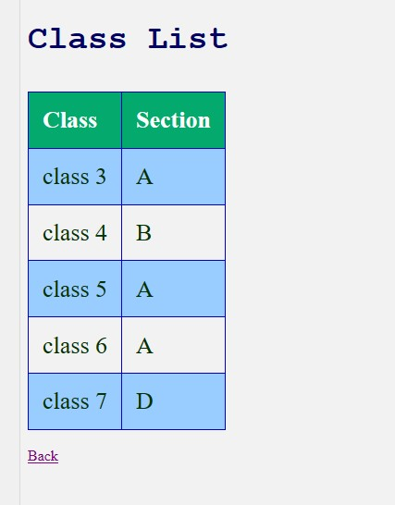

* 1. **Subject List :-**

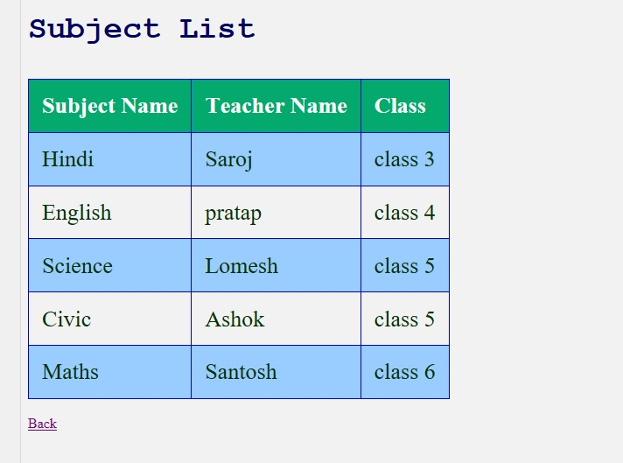

* 1. **Class Report:-**

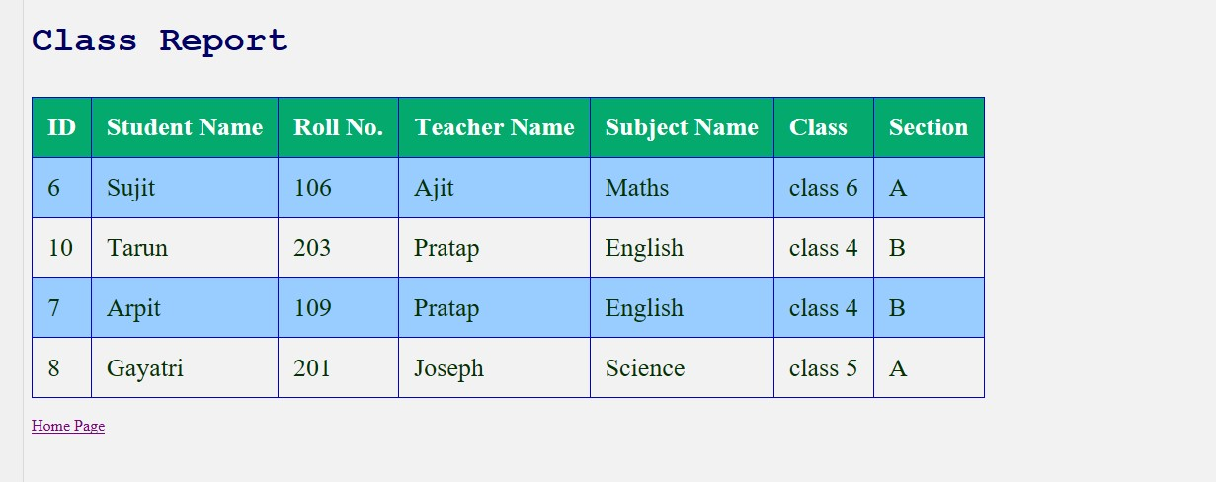

1. **Admin Page**

If you enter wrong username or password, it will show the message of Invalid username or password, and redirect to Login page.

